SCHOOL OF COMPUTER SCIENCE AND ARTIFICIAL INTELLIGENCE |  |  |  |  | DEPARTMENT OF COMPUTER SCIENCE ENGINEERING
Program Name: B. Tech |  |  |  | Assignment Type: Lab |  |  | Academic Year:2025-2026
Course Coordinator Name |  |  |  | Venkataramana Veeramsetty
Instructor(s) Name |  |  |  | Dr. V. Venkataramana (Co-ordinator)  Dr. T. Sampath Kumar  Dr. Pramoda Patro  Dr. Brij Kishor Tiwari  Dr.J.Ravichander  Dr. Mohammand Ali Shaik  Dr. Anirodh Kumar  Mr. S.Naresh Kumar  Dr. RAJESH VELPULA  Mr. Kundhan Kumar  Ms. Ch.Rajitha  Mr. M Prakash  Mr. B.Raju  Intern 1 (Dharma teja)  Intern 2 (Sai Prasad)  Intern 3 (Sowmya)  NS_2 ( Mounika)
Course Code |  |  | 24CS002PC215 | Course Title |  | AI Assisted Coding
Year/Sem |  |  | II/I | Regulation |  | R24
Date and Day  of Assignment |  |  | Week9 - Tuesday | Time(s)
Duration |  |  | 2 Hours | Applicable to  Batches
AssignmentNumber:16.2(Present assignment number)/24(Total number of assignments)
 | Q.No. | Question |  |  |  |  |  | Expected Time  to complete
 | 1 | - Display all records from the employee’s table.  - Prompt: Display all records from the employee’s table.    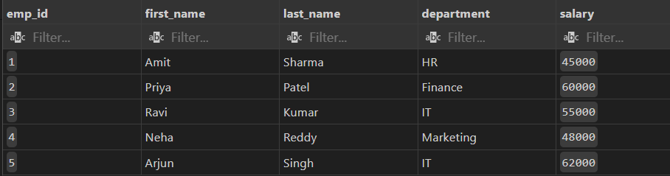  - 2. Display only employee names and their departments.  Prompt: Display only employee names and their departments  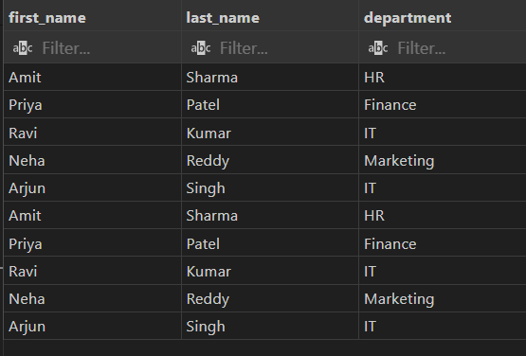  - 3. Show unique department names.  Prompt: Show unique department names.  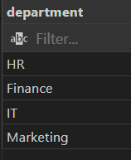  - 4. Find employees with salary greater than 50000.  Prompt: Find employees with salary greater than 50000.  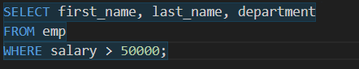  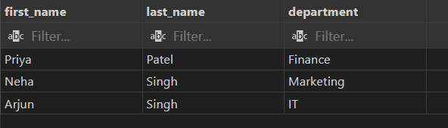  - 5. Find employees from the IT department.  Prompt: Find employees from the IT department.  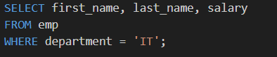  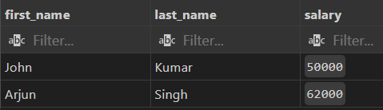  - 6. Display employees hired after 2020.  Prompt: Display employees hired after 2020.  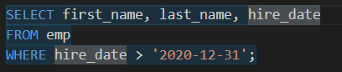  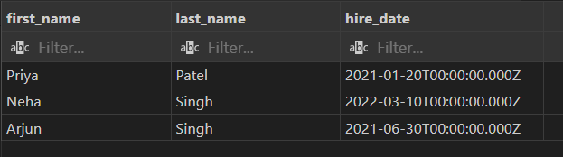  - 7. Show employees in ascending order of salary.  Prompt: Show employees in ascending order of salary.  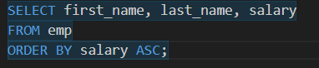  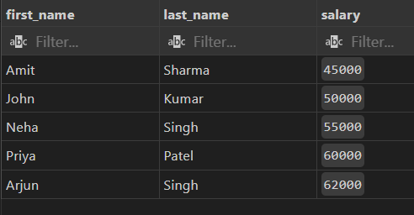  - 8. Show top 3 highest-paid employees.  Prompt: Show top 3 highest-paid employees.  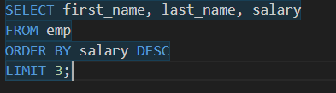  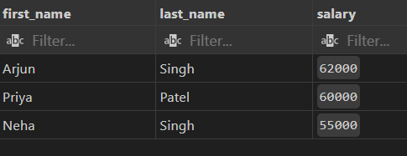  - 9. Count total employees in the company.  Prompt: Count total employees in the company.  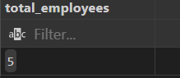  - 10. Find the average salary of employees.  Prompt: Find the average salary of employees.  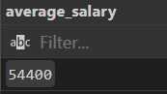  - 11. Find the highest and lowest salary.  Prompt: Find the highest and lowest salary.  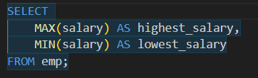  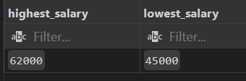  - 12. Find total salary expenditure per department.  Prompt: Find total salary expenditure per department.  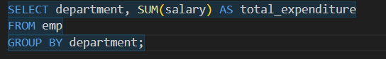  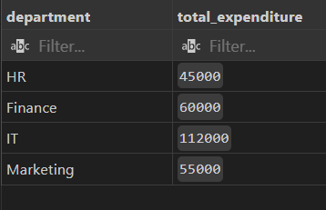  - 13. Display departments having more than one employee.  Prompt: Display departments having more than one employee.  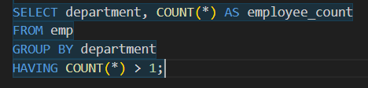  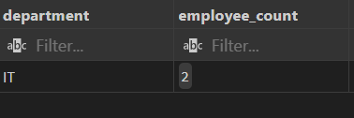  - 14. Show average salary by department.;  Prompt: Show average salary by department.  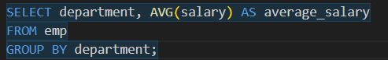  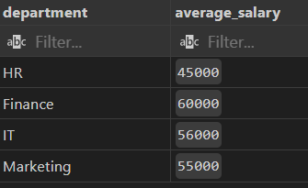  - 15. Count employees hired each year.  Prompt: Count employees hired each year.  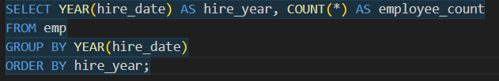  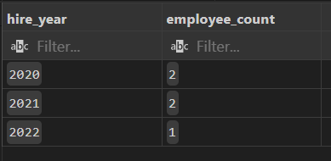  - 16. List employees with their department locations.  Prompt: List employees with their department locations.  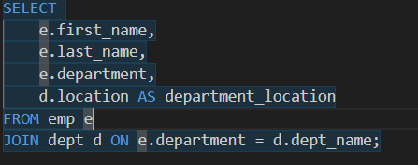  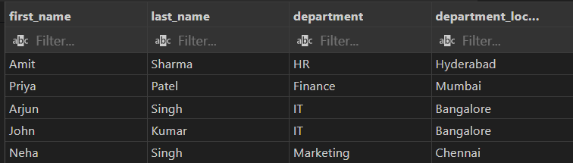  - 17. Find employees working in Bangalore.  Prompt: Find employees working in Bangalore.  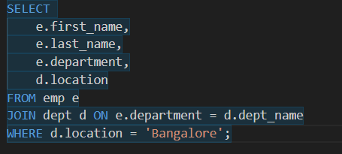  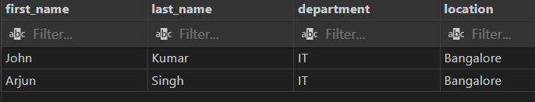  - 18. Display all employees even if they don’t belong to a department.  Prompt: Display all employees even if they don’t belong to a department.  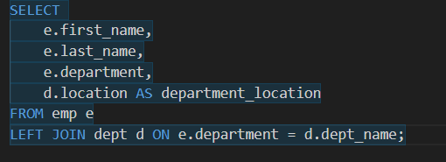  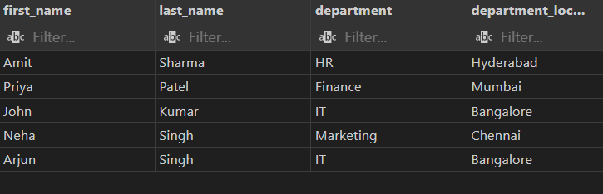  - 19. Find departments with no employees.  Prompt: Find departments with no employees.  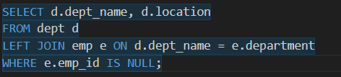  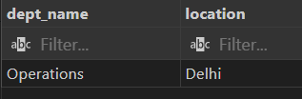  - 20. Count employees in each department.  Prompt: Count employees in each department.  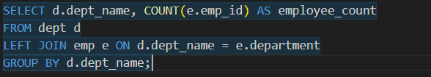  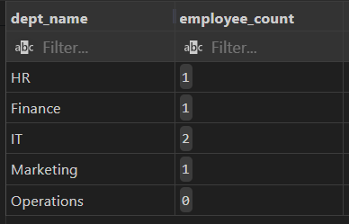  - 21. Find employees earning above average salary.  Prompt: Find employees earning above average salary.  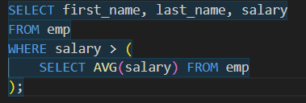  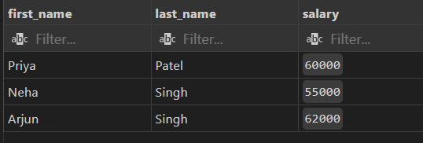  - 22. Find the department with the highest average salary.  Prompt: Find the department with the highest average salary.  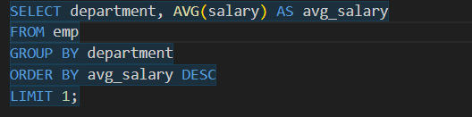  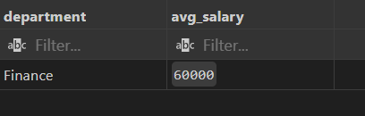  - 23. Find employees hired most recently.  Prompt: Find employees hired most recently.  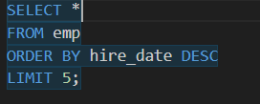  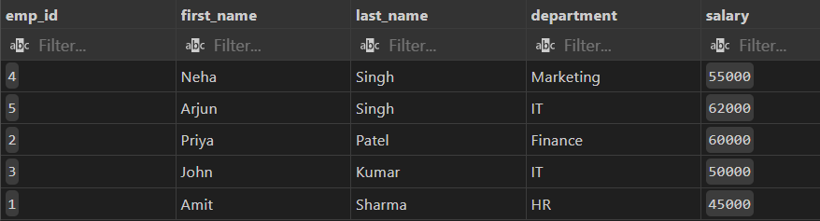  - 24. Find employees earning the second highest salary.  Prompt: Find employees earning the second highest salary.  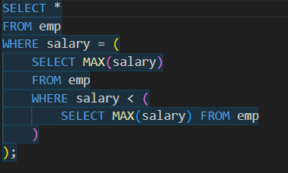  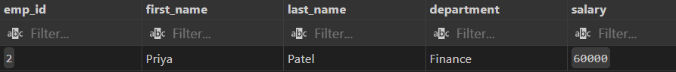  - 25. Find all employees in the same department as 'Amit Sharma'.  Prompt: Find all employees in the same department as 'Amit Sharma'.  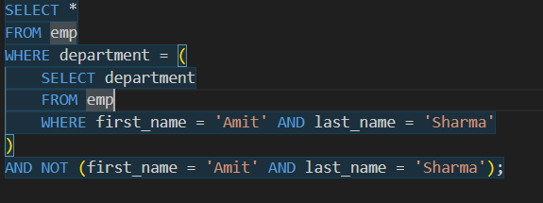  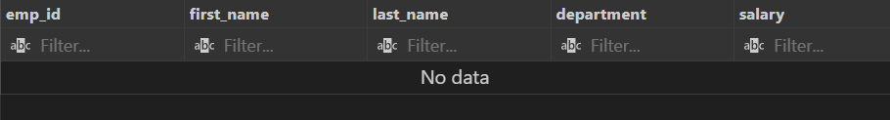  - 26. Increase salary by 10% for IT employees.  Prompt: Increase salary by 10% for IT employees  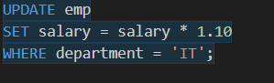  - 27. Change department of employee 'Ravi' to Marketing.  Prompt: Change department of employee 'Ravi' to Marketing  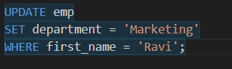  - 28. Delete employees with salary below 40000.  Prompt: Delete employees with salary below 40000.    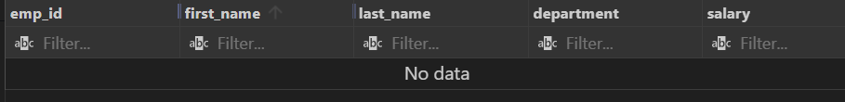  29. Add a new column 'email' to employees.  Prompt: Add a new column 'email' to employees.  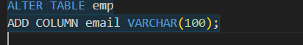  30. Update email IDs for all employees.  Prompt: Update email IDs for all employees.  31. 31. Find top 2 departments by average salary.  Prompt: Find top 2 departments by average salary.  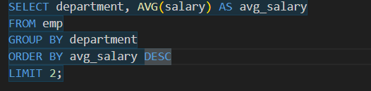  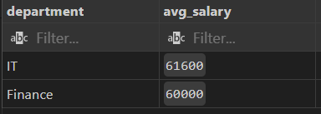  32. 32. Find how many employees work in each city.  Prompt: Find how many employees work in each city.  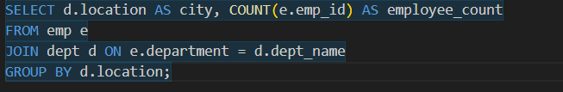  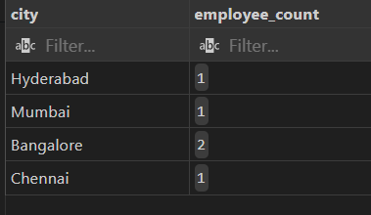  33. 33. Show employee count and total salary together.  Prompt: Show employee count and total salary together.  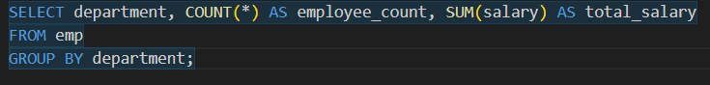  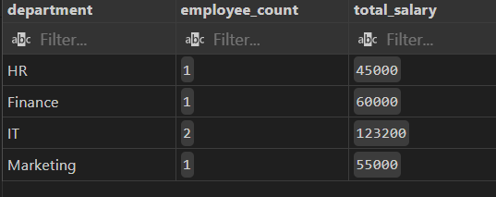  34. 34. Display employees with names starting with 'A'.  Prompt: Display employees with names starting with 'A'.  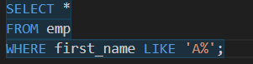  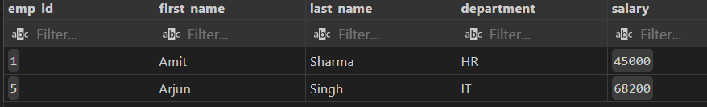  35. 35. Display employees whose last name ends with 'a'.  Prompt: Display employees whose last name ends with 'a'.  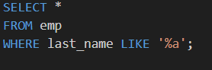  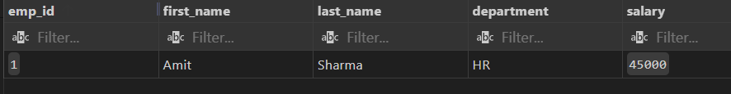  36. 36. Find employees hired in 2020.  Prompt: Find employees hired in 2020.  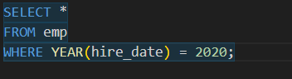  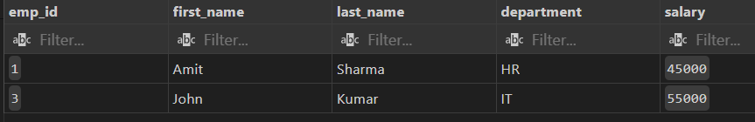  37. 37. Show number of days since each employee was hired.  Prompt: Show number of days since each employee was hired.  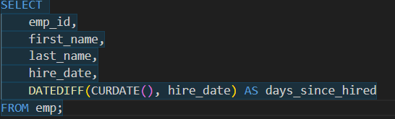  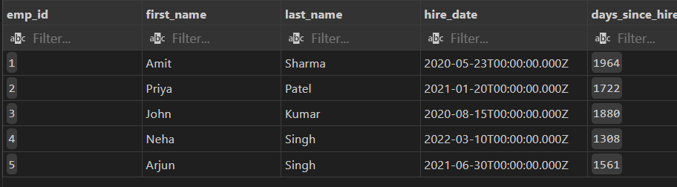  38. 38. Display employee names in uppercase.  Prompt: Display employee names in uppercase.  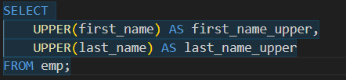  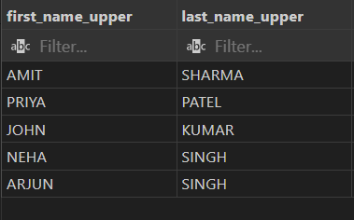  39. 39. Concatenate first and last names.  Prompt: Concatenate first and last names.  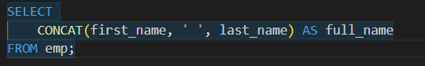  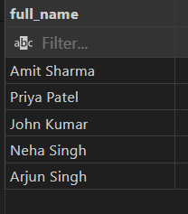  40. 40. Find employees whose salary is between 45000 and 60000.  Prompt: Find employees whose salary is between 45000 and 60000.  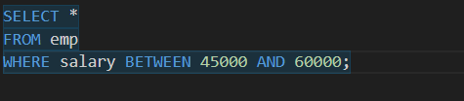  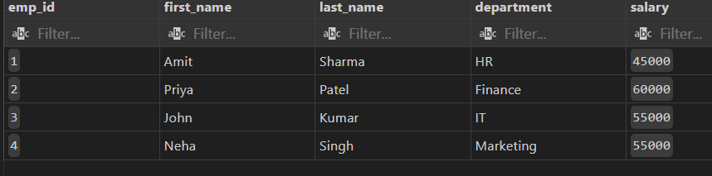  41. 41. Create a view for high salary employees (>55000).  Prompt: Create a view for high salary employees (>55000).  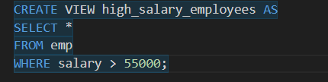  42. 42. Display all records from the view.  Prompt: Display all records from the view.  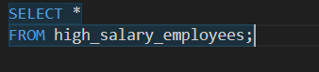  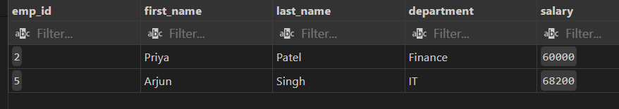  43. 43. Add NOT NULL constraint to department name.  Prompt: Add NOT NULL constraint to department name.  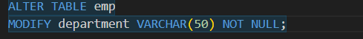  44. 44. Drop the view.  Prompt: . Drop the view.  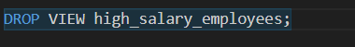  45. 45. Rename the employees table to staff.  Prompt: Rename the employees table to staff.    46. 46. Create a backup copy of the employees table.  Prompt: Create a backup copy of the employees table.  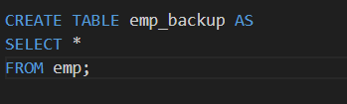  47. 47. Delete all data but keep the structure.  Prompt: Delete all data but keep the structure.    48. 48. Drop the employees backup table.  Prompt: Drop the employees backup table.    49. 49. Create an index on employee last name.  Prompt: Create an index on employee last name.  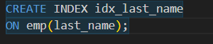  50. 50. Drop the index.  Prompt: Drop the index.   |  |  |  |  |  | Week9 - Monday

Employee Table
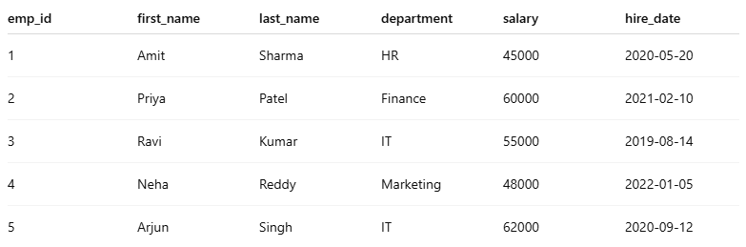

Department Table

